I collaborated extensively with interdisciplinary researchers on the design and analysis of longitudinal and cross-sectional health surveys at local, national, and international levels.

The University of Dioxin Exposure Study (UMDES) was undertaken in response to concerns that the discharge of dioxin-like compounds from the Dow Chemical Company facilities in Midland, Michigan, resulted in contamination of soils in the Tittabawassee River floodplain and areas of the city of Midland, Michigan, leading to an increase in residents’ body burdens of polychlorinated dibenzodioxins and polychlorinated dibenzofurans. The sample design was a stratified, multistage area probability sample of households and persons.
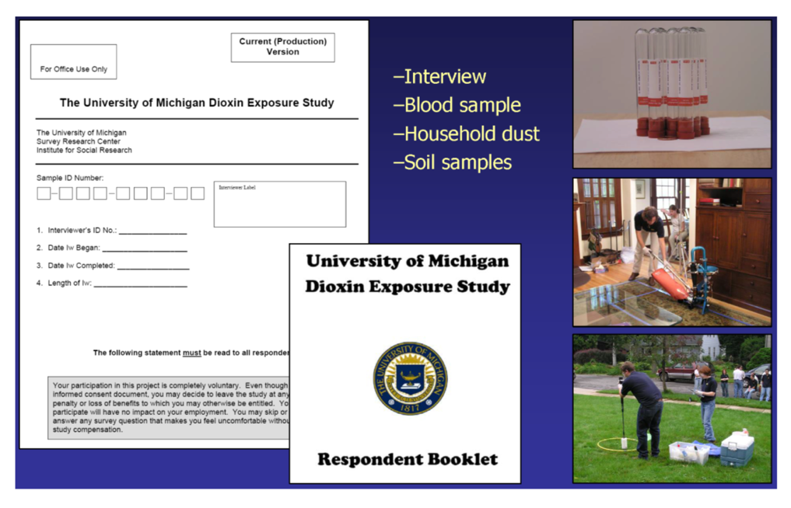
Selected publications:
- Garabrant, D., Franzblau, A., Lepkowski, J., Gillespie, B., Adriaens, P., Demond, A., Ward, B, LaDronka, K., Hedgeman, E., Knutson K., Zwica, L., Olson, K., Towey, T., Chen, Q., and Hong, B. (2009). “The University of Michigan Dioxin Exposure Study: methods for an environmental exposure study of polychlorinated dioxins, furans and biphenyls”, Environmental Health Perspectives, 117, 803-810.
- Hedgeman, E., Chen, Q., Hong, B., Chang C-W., Olson K., LaDronka, K., Ward, B., Adriaens, P., Demond, A., Gillespie, B., Lepkowski, J., Franzblau, A., and Garabrant, D. (2009). “The University of Michigan Dioxin Exposure Study: population survey results and serum concentrations for polychlorinated dioxins, furans and biphenyls”, Environmental Health Perspectives, 117, 811-817.

The 2013-2014 National Drug Abuse Treatment System Survey (NDATSS-2013) provides management- and policy-relevant information about substance abuse treatment in the United States. Substance abuse treatment programs are chosen for the study by random selection from a list of all such programs stratified by program types, provided by the Substance Abuse and Mental Health Services Administration (SAMHSA). The data collection was done through interviews with program directors and clinical supervisors.
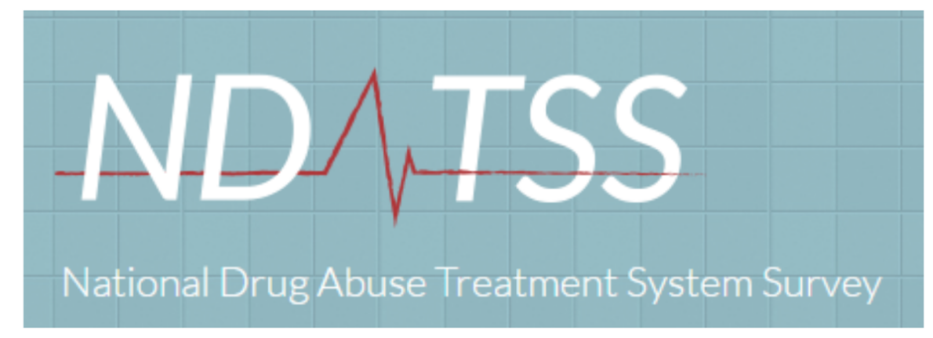
Selected publications:
- D’Aunno, T., Friedmann, P. D., Chen, Q., and Wilson, D. M. (2015). “Integration of substance abuse treatment organizations into Accountable Care Organizations: results from a national survey”, Journal of Health Politics, Policy, and Law, 40(4), 795-817.
- D’Aunno, T., Pollack, H., Chen, Q., and Friedmann, P. D. (2017). “Linkages between patient-centered medical homes and addiction treatment organizations: results from a national survey”, Medical Care, 55(4): 379-383.

